**Implementing Code Using Xampp**

**Creating Tables**

When implementing the code, I decided to create the tables for each entity containing their attributes. After this, I would then add the foreign key constraints (using ALTER statement). This is because I was having problems including the foreign key initially when creating the tables.

**1.Creating Tables**

**Sales Representative:**

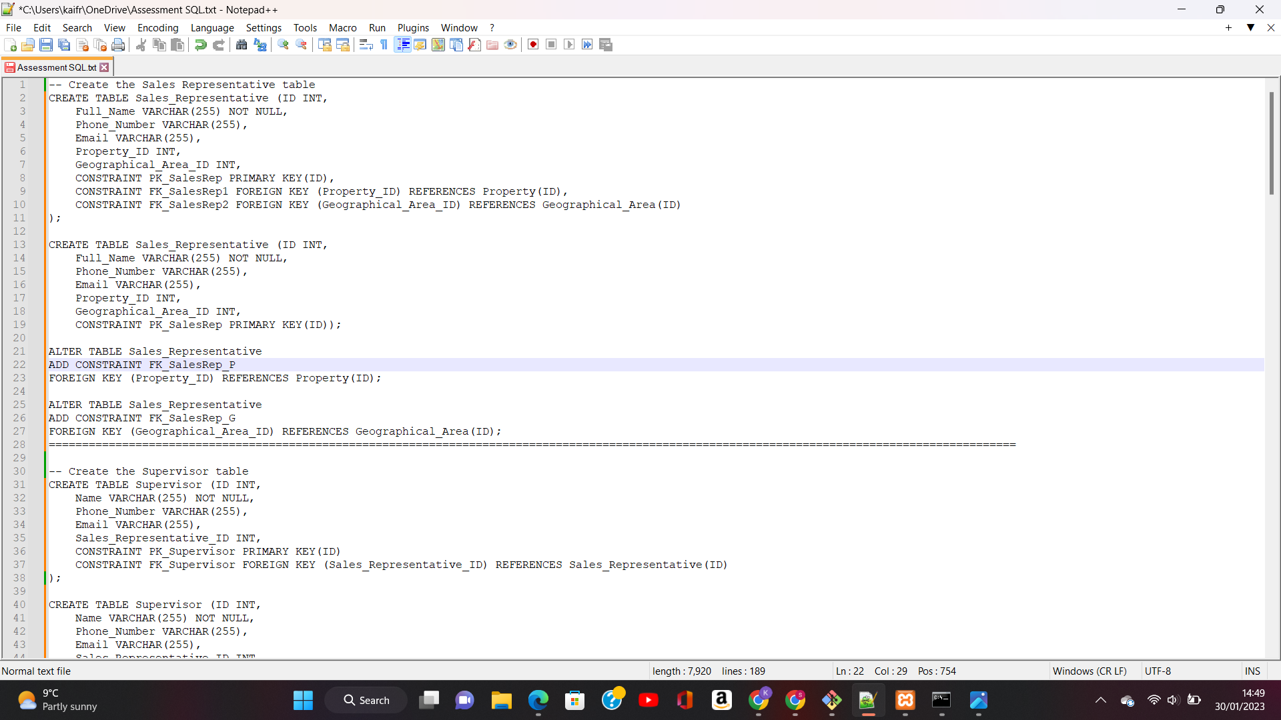

**Sales Supervisor:**

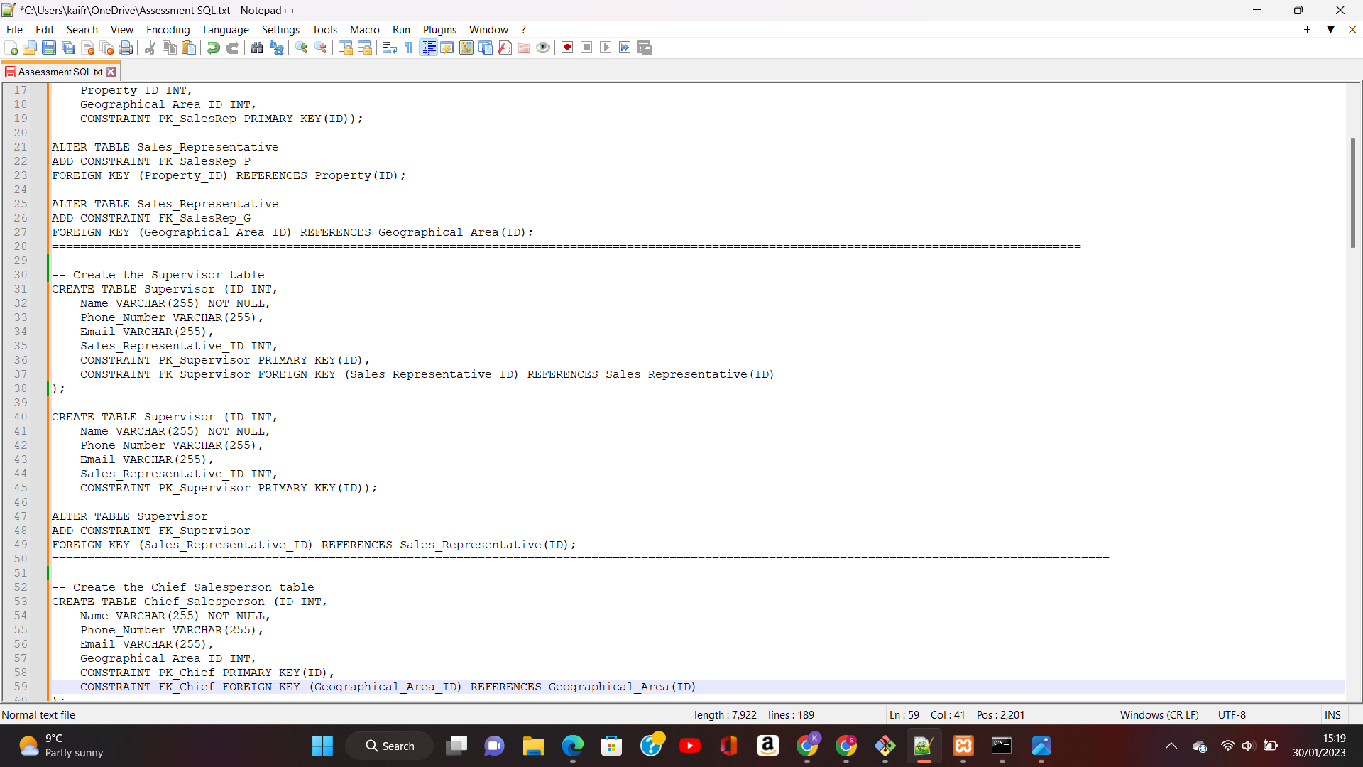

**Chief Salesperson:**

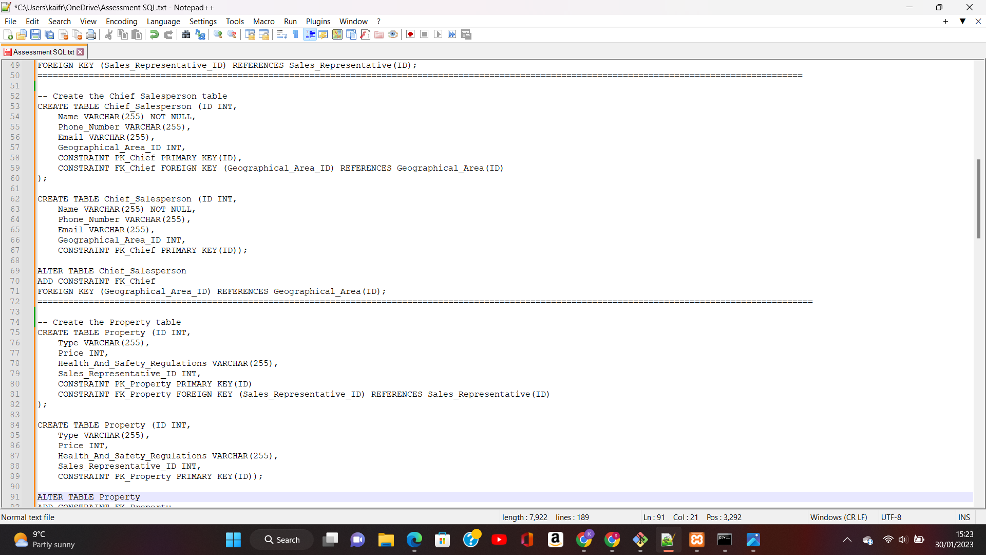

**Property:**

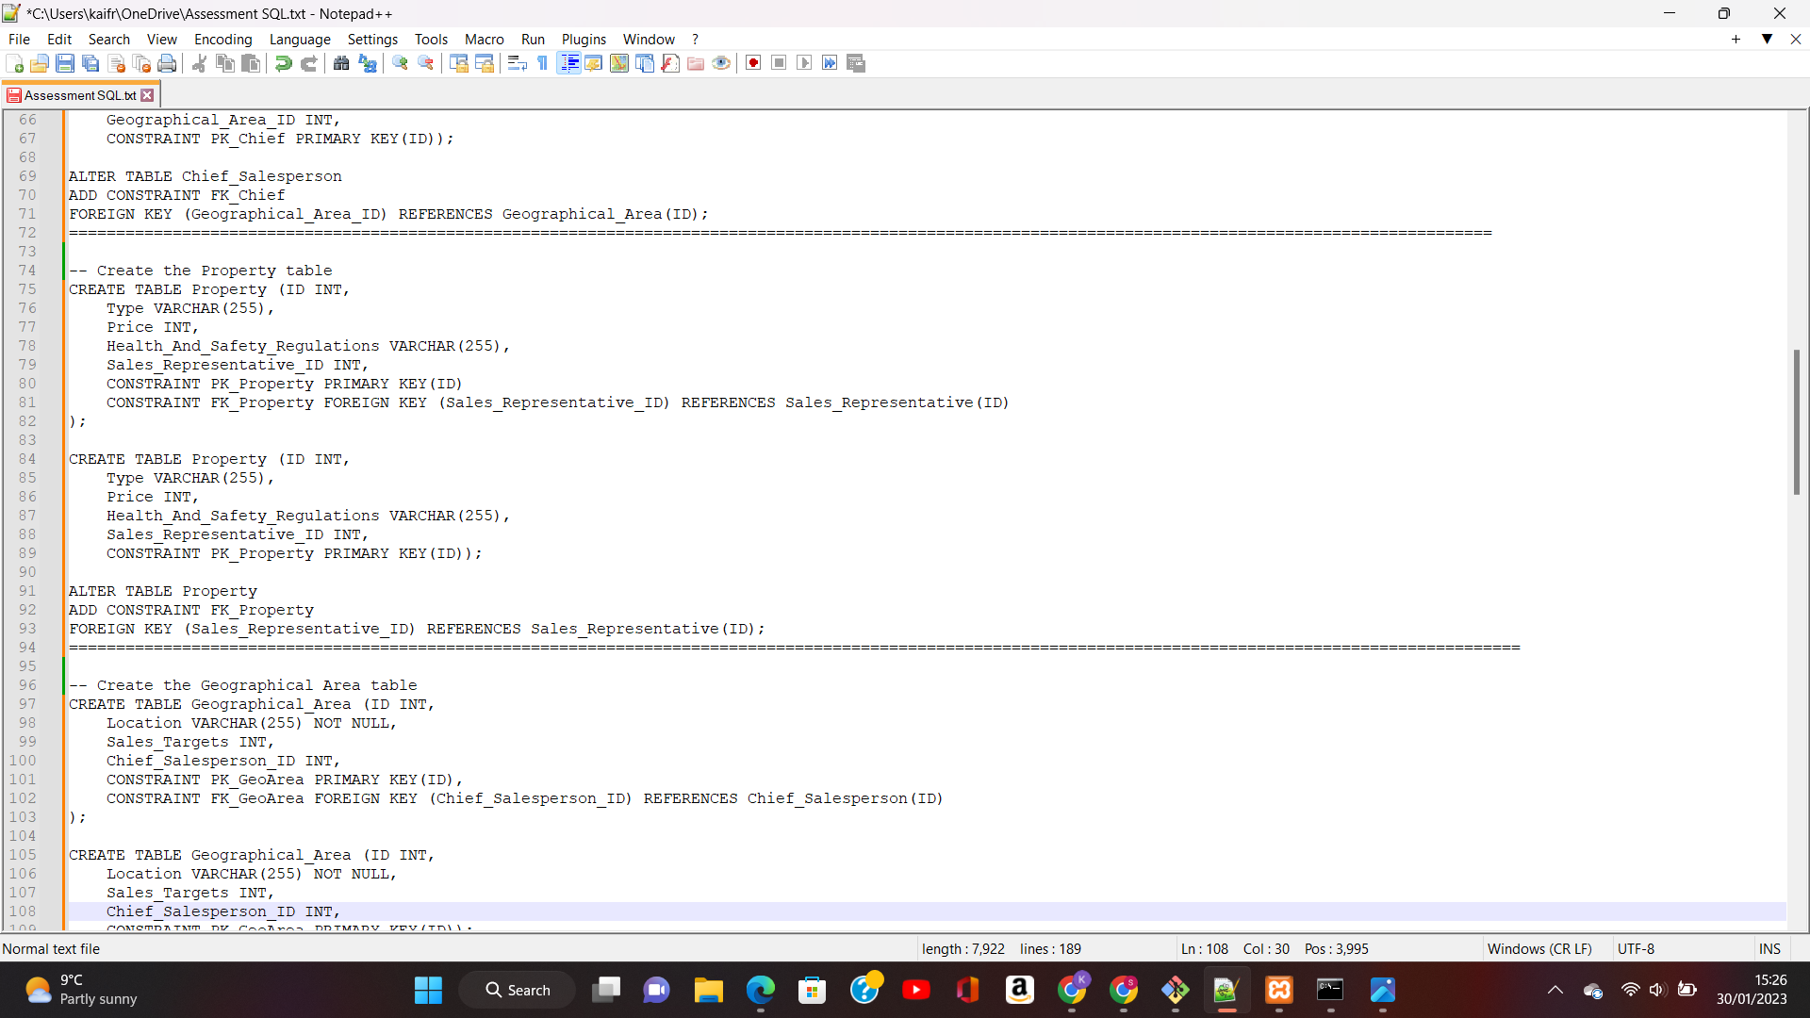

**Geographical Area:**

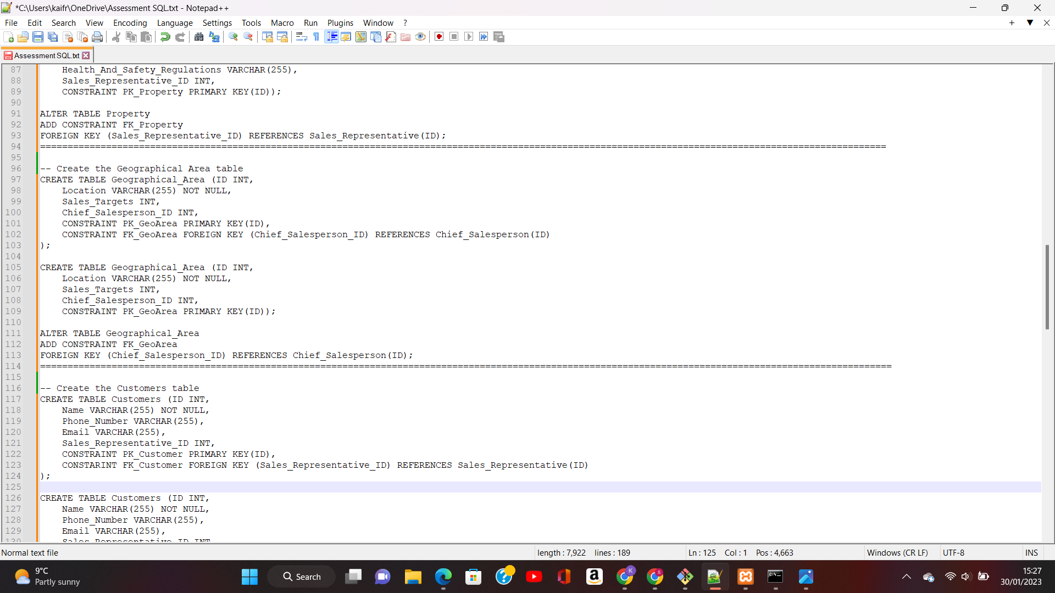

**Customers:**

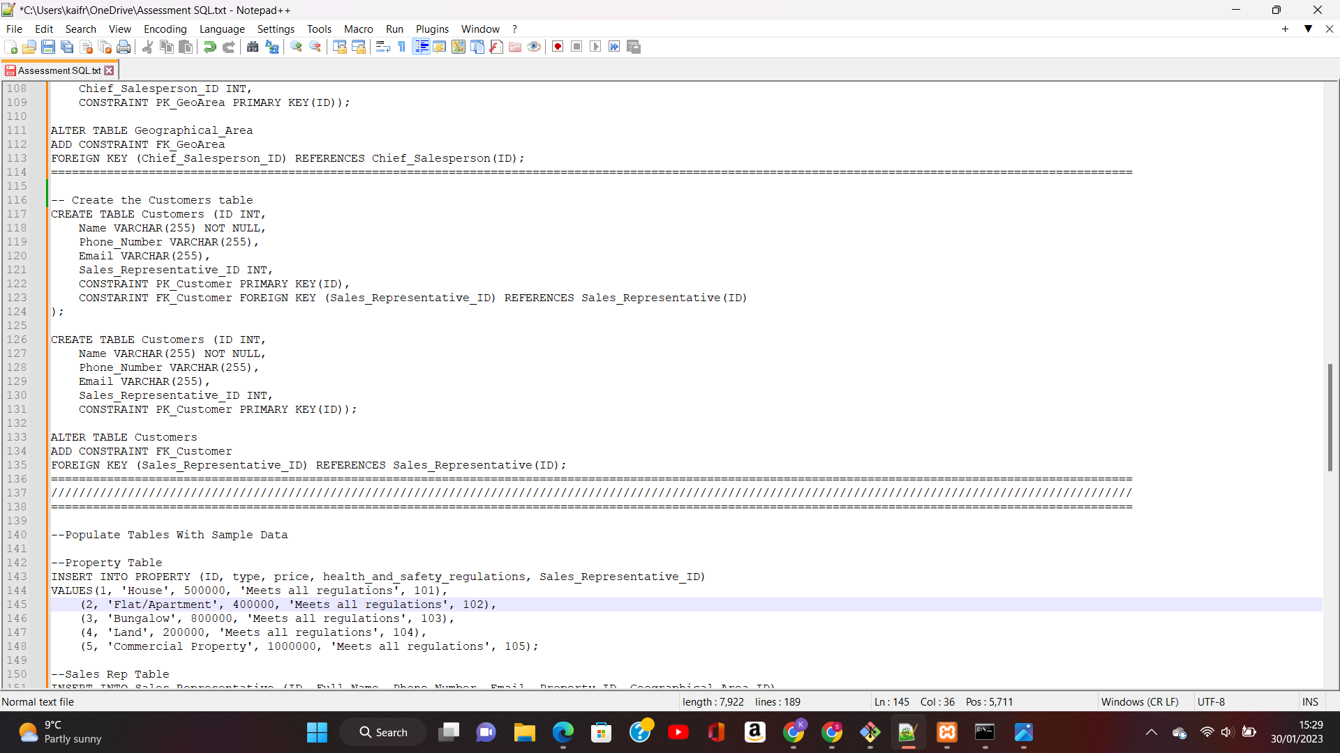

**2.Adding Foreign Key Constraints**

**Sales Representative Table:**

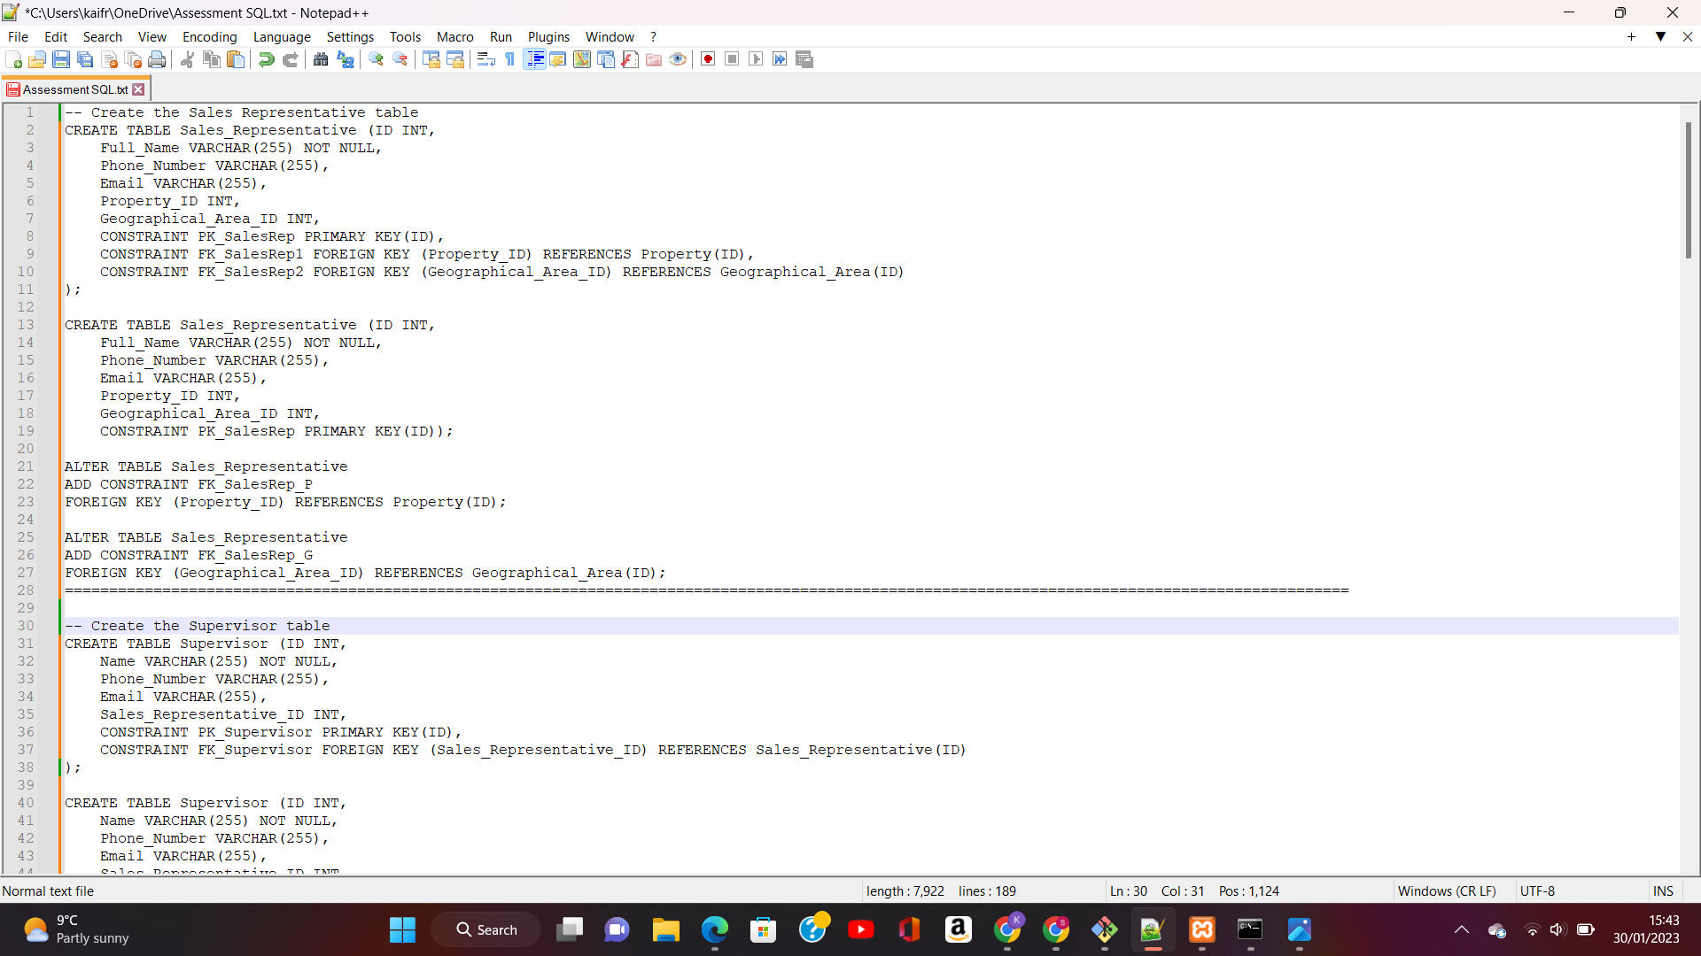

**Sales Supervisor Table:**

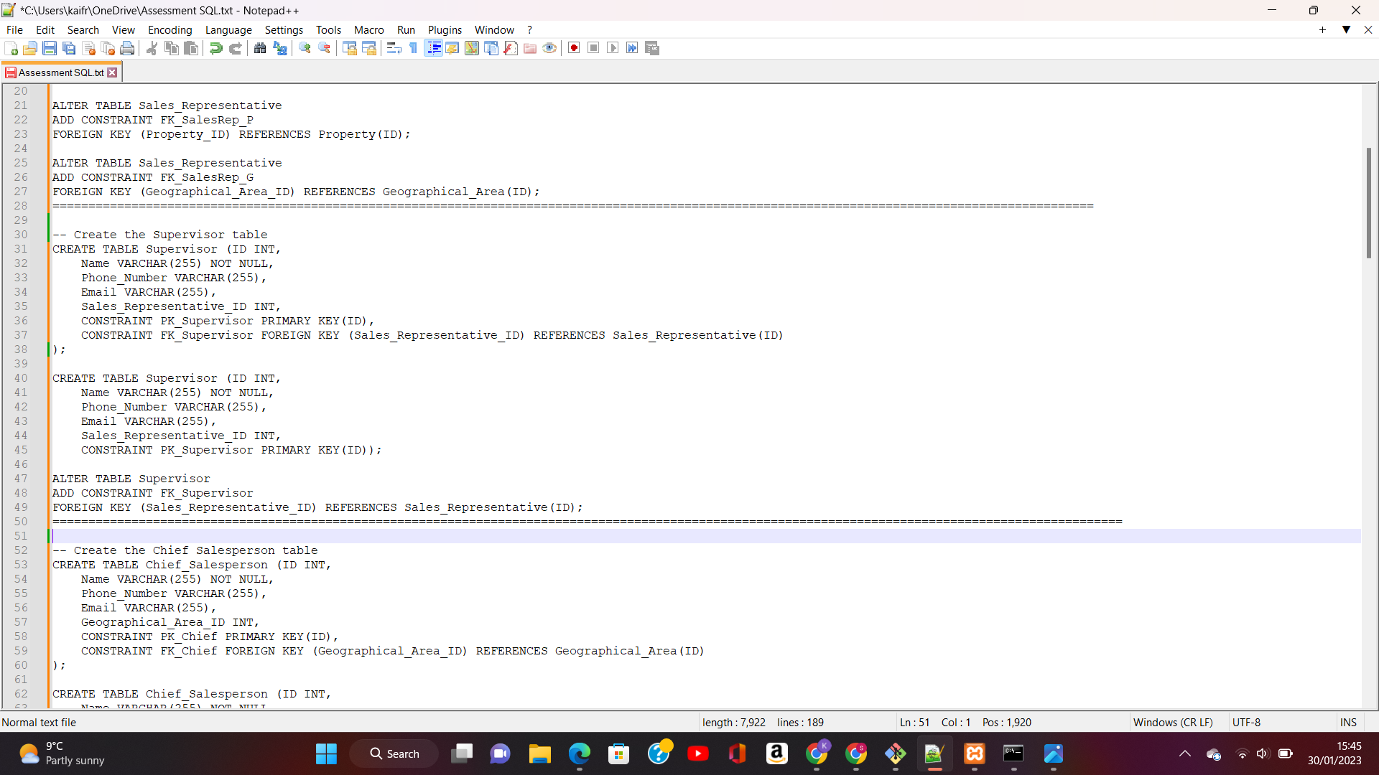

**Chief Salesperson Table:**

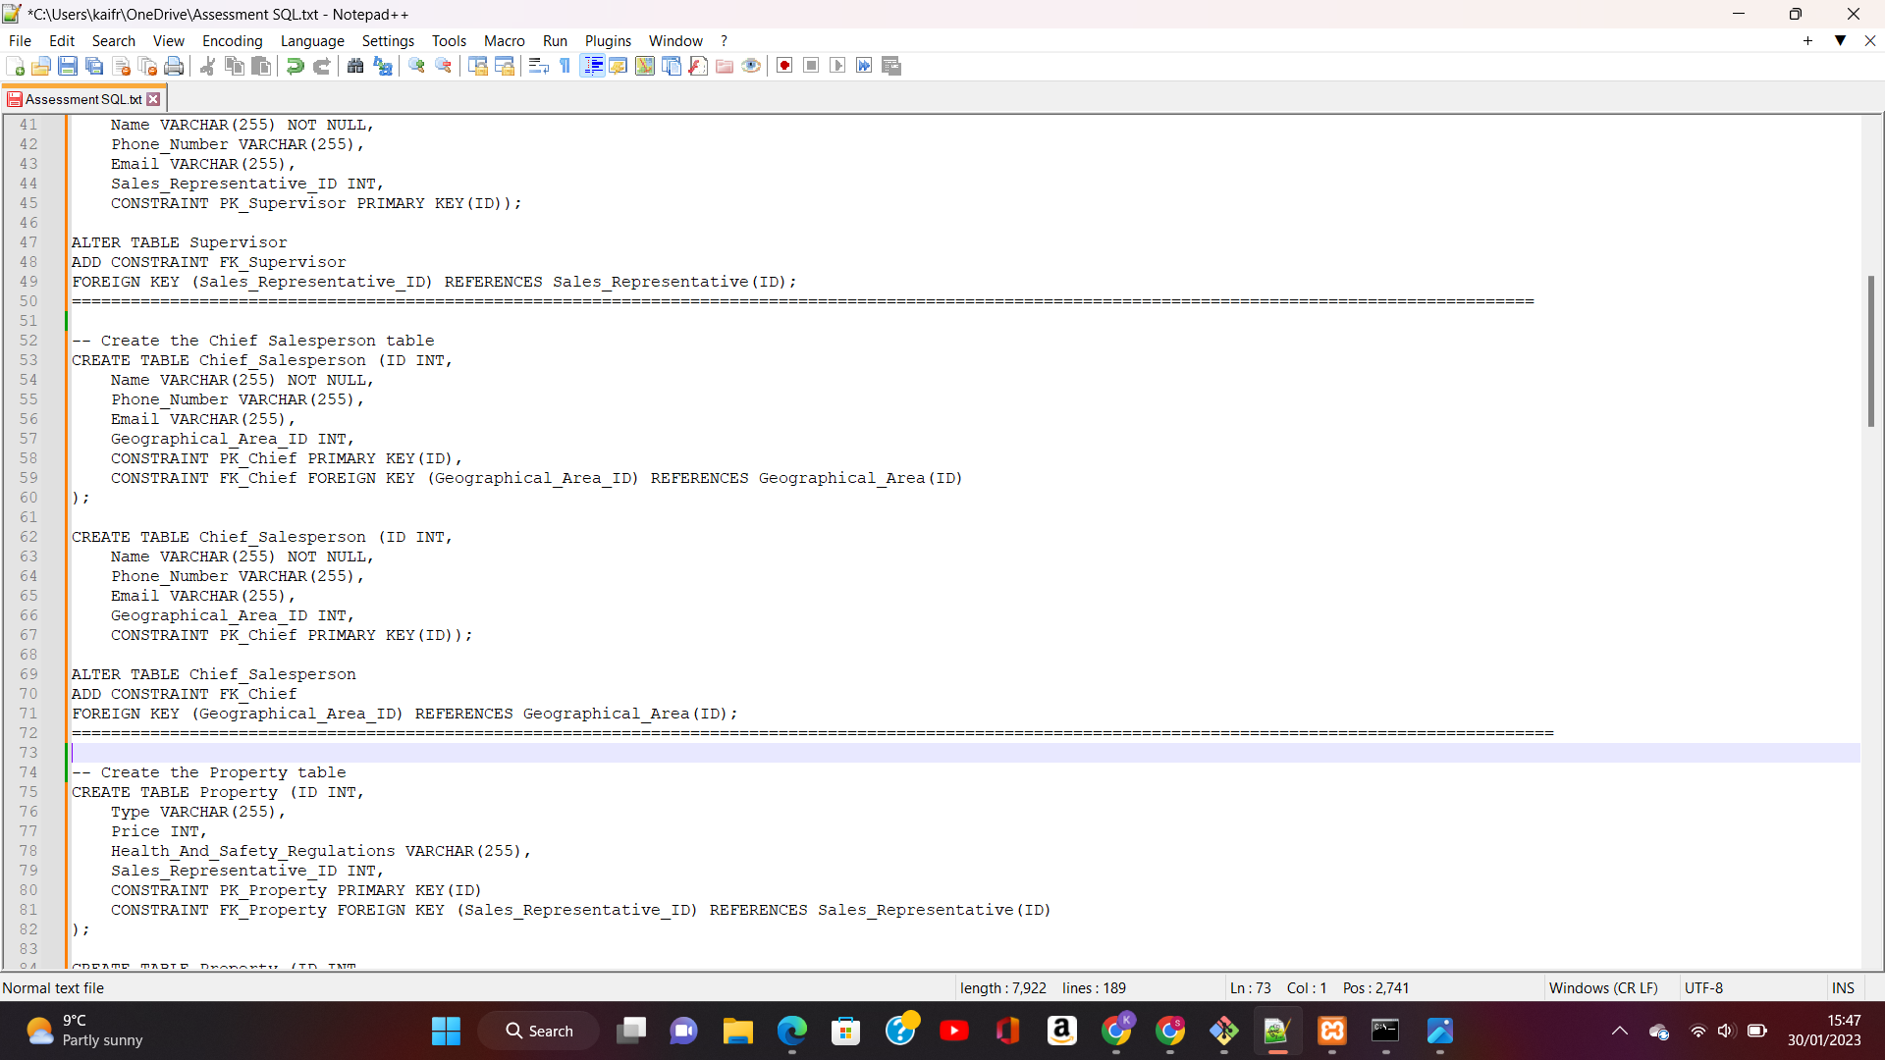

**Property Table:**

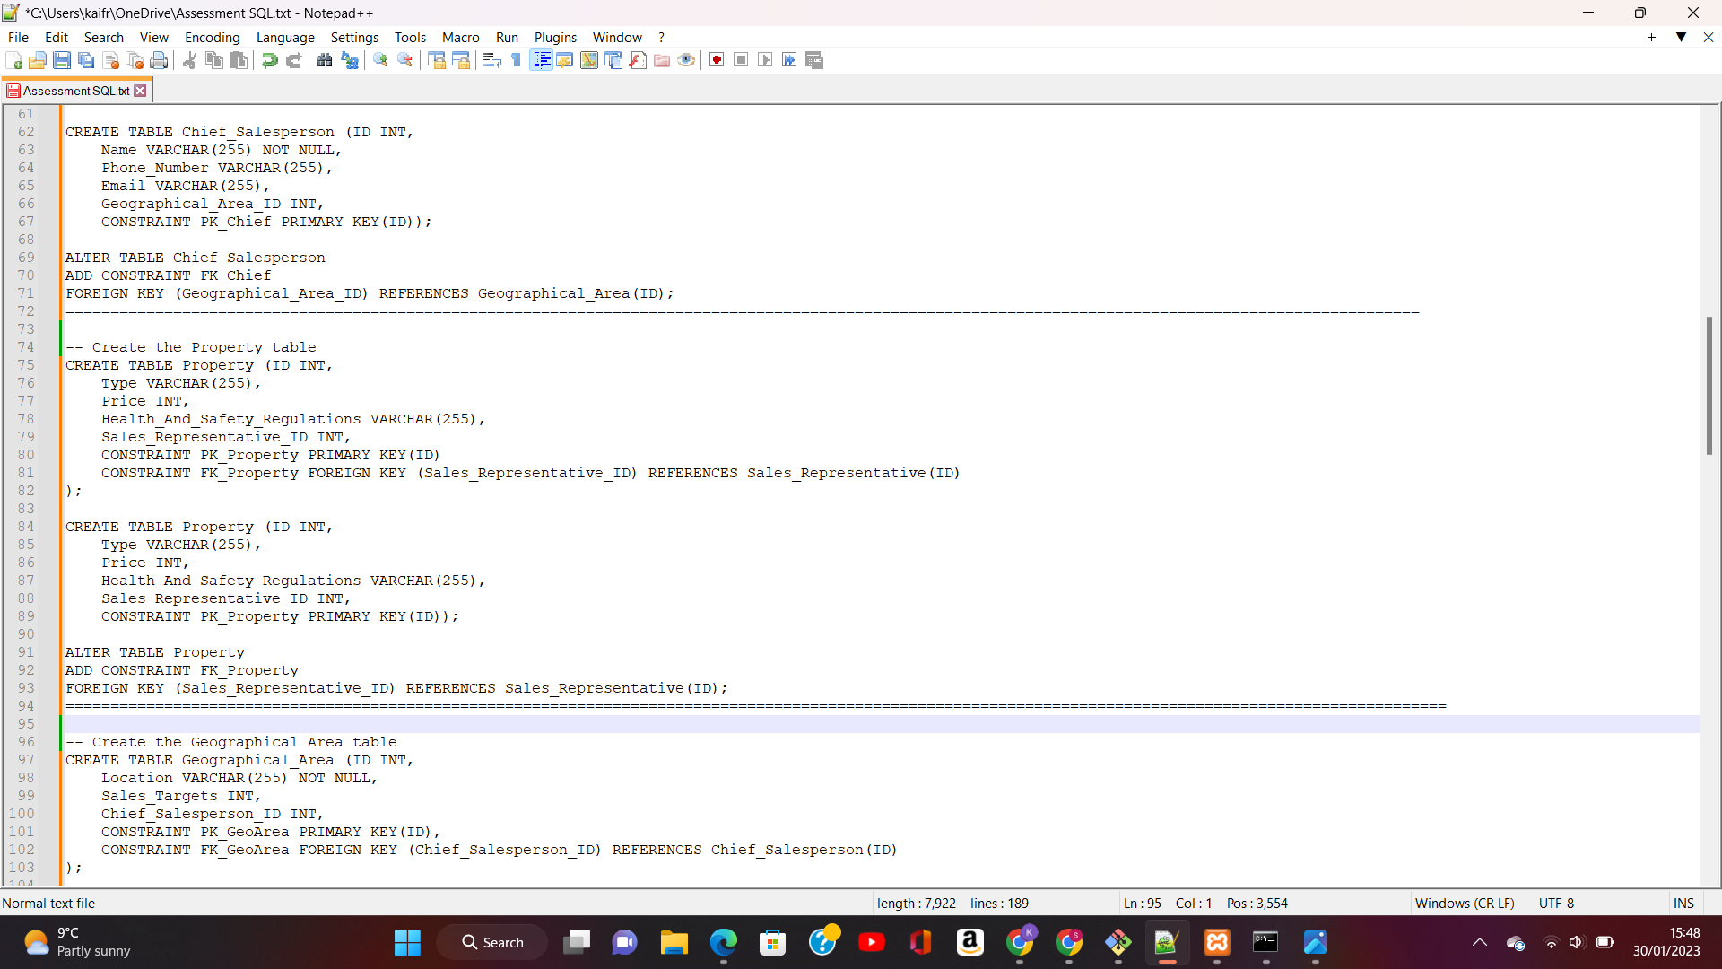

**Geographical Area Table:**

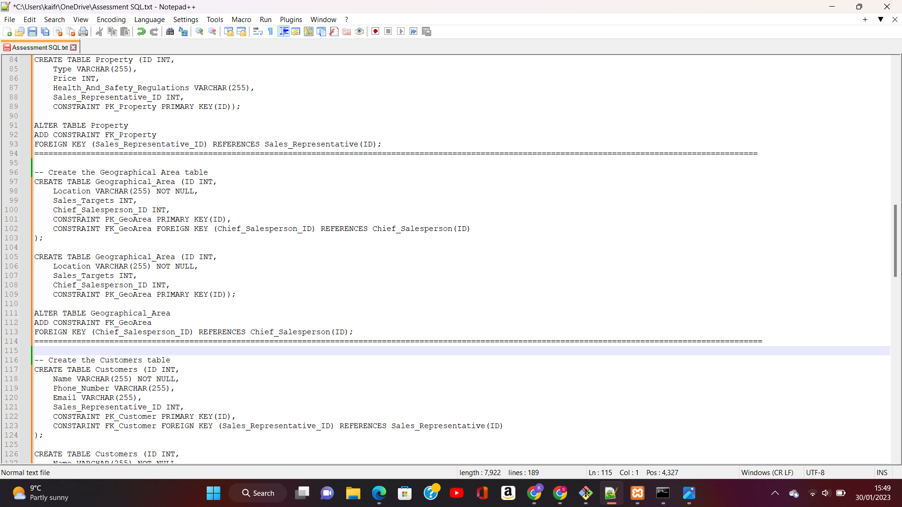

**Customers Table:**

